Moving to great essay writing! 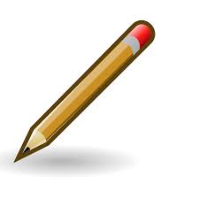

Criteria | Awesome! | Good! | Let’s talk!
Introduction connects with the question asked | The introduction includes words from the prompt question, and also adds the writer’s idea(s) | The introduction includes words from the prompt | Please connect the first sentence with the prompt question
Essay central idea controls the writing’s main point | The essay controlling idea is insightful and original | Has a controlling idea | What is your main controlling idea?
Text evidence from both readings supports the essay central idea | Original transitional phrases are used to link ideas | Has a few transitions that are common connecting words | Please add more text evidence
Transitional words are appropriate and not common | Transitional words and phrases nicely connect paragraphs and sentences and are unique | Transitions are present | Add transitional words or phrases
Precise words | Concrete and precise, fresh new striking words used | Some concrete words | Please add concrete words
Conclusion follows the controlling idea and sums up and may lead to a new thought | Conclusion sums up the essay central idea using fresh new language and takes the thoughts to a new next step | Conclusion sums up the essay central idea | Please add a summing up conclusion
Conventions | Fine sentencing, usage, spelling, punctuation | Just a few errors in sentencing, spelling, usage, punctuation | Please check sentence, spelling and punctuation  errors

