Powering Up for MCAS 2.0

Katherine Scheidler, Ed.D
kayscheidler@hotmail.com
617-634-9733
Big Picture:
- Common Core Benefits:
By state law, CCSS is tested to assess learning
Guide to learning for all students
Simply good basic reading understandings
Reading and literary analysis
NATIONAL standards – broad internet resources
When we teach the standards, in such a way that students learn
we see results in tests

- Know the Standards for your grade level
www.Corestandards.org -- best site for easy access to your grade level standards
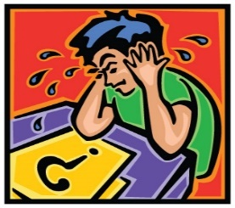
- Tests:
Assessment of learning
Are we teaching reading ability for all students?
Are students learning what we’re teaching?
Assessment of reading and writing ability
When we teach students in such a way that they’re learning, this shows on the test
https://parcc.pearson.com/practice-tests/english/
Give a chance for every child: “Born poor, stay poor” Break the cycle of poverty
Jeb Bush: “Without the test, no one would pay attention.”
Not just high demographic students learning; All learning the same things
Student Growth Percentile: Have students moved from one level to the next level

How To:
- Not just teaching for the test: Short-term learning, not teaching for understanding.
Teaching for understanding:
Use Released Sample items as assessments
Test Prep focus on practice tests doesn’t teach for understanding.

Best Practice:

- Integrate Standards learning into teaching
Name the skill
Common reading skills: close reading, central idea, inference, read for information

- Supplement district program with Standards learning.
Vygotsky: Zone of Proximal Development: Teach at the next best level up
We can only learn at the next best step up for us.

- Every student can learn: Takes longer, direct instruction, reinforcement, alternative learning styles methods, one-on-one, learn from peers, active learning activities, make cultural connections: What’s engaging reading for that student? Build in “baby steps” to learning, create a bank of structured supports to scaffold learning,

Scaffold learning

- Build reading fluency: Culture of reading, along with comprehension checks: alternative reading for struggling readers, class libraries, take-home personalized readings, independent choice reading
Independent reading builds reading comprehension, fluency, vocabulary

MCAS 2.0
Part B Question, Evidence. Evidence pieces can help with correct choice.
Strategies to tackle more challenging reading passages: look at visuals, terms students know, read for an area of understanding, read the questions for process of elimination,

- Collect similar skills passages focus for skill learning. close reading, inference, Central idea,
Reinforce this learning over the school year as the skills appear in readings.

Connecting reading and writing: Central idea Write about a situation or activity
What is the lesson learned? Engaged class discussion: Write your opinion.

- Mr. Brandon’s School Bus sample readings: write a vignette. Add a thought on the brief scene
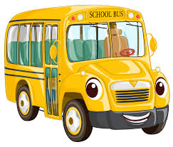
Mr. Grammar
Simile: a phrase that uses the word like or as to describe someone or something by comparing it with someone or something else that is similar.
Hearing a high-pitched squeal from the back half of the bus, I used my extensive knowledge of the English language and chose the only simile that would be appropriate for the situation.
With my bus-driver authoritative voice, I yelled, “Hey, whoever is doing that, stop squealing like a little girl!” Then I settled back in the glow of a job well done.
Immediately a little blonde head popped up and said, “But I am a little girl.” The squealing continued, and I hummed softly to myself as we continued down the road.
Well played, little girl. Well played. From “Mr. Brandon’s School Bus”

